Project Part I

By: Brandon Faulkner

Class: IE-3301-009

UTA ID: 1001988125

“I Brandon Faulkner did not give or receive any assistance on this project, and the report submitted is wholly my own.”

**DATA SET (Normal Distribution)**

**Definition of Variable:** Weight in pounds of adult males

**Data Collection:** This data set is a collection of 100 adult male weights in pounds. I was able to find this set online, but it would not be too hard to replicate. For example, you could wait outside of a busy store and ask any adult male walking by for their weight and record the data.

|  |  |  |  |  |  |  |  |  |  |
| --- | --- | --- | --- | --- | --- | --- | --- | --- | --- |
| 196 | 187 | 161 | 204 | 192 | 211 | 190 | 181 | 151 | 179 |
| 229 | 245 | 239 | 210 | 239 | 195 | 162 | 252 | 221 | 152 |
| 180 | 156 | 218 | 176 | 211 | 172 | 252 | 210 | 205 | 216 |
| 192 | 227 | 188 | 154 | 183 | 235 | 217 | 180 | 175 | 204 |
| 151 | 175 | 218 | 223 | 150 | 217 | 161 | 219 | 169 | 239 |
| 169 | 256 | 205 | 255 | 226 | 260 | 254 | 166 | 235 | 160 |
| 208 | 222 | 238 | 196 | 215 | 251 | 154 | 208 | 247 | 224 |
| 249 | 223 | 179 | 225 | 206 | 198 | 152 | 260 | 205 | 199 |
| 201 | 178 | 209 | 236 | 238 | 251 | 249 | 200 | 217 | 197 |
| 173 | 180 | 195 | 185 | 200 | 205 | 194 | 208 | 174 | 251 |

**Data Set (pounds):**

**Mean:** 204.55

**Standard Deviation:** 30.4333599

**Frequency Table**

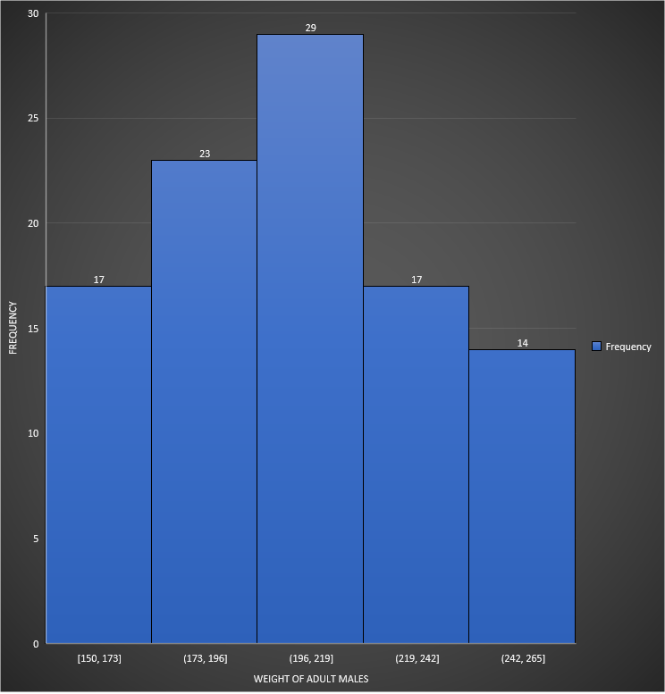**Histogram**

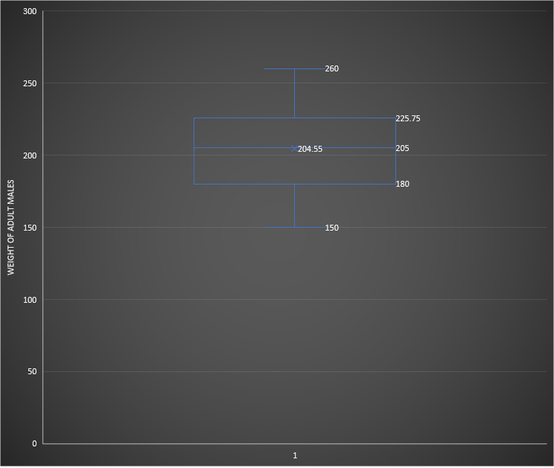**Box Plot Chart**

**Quartile Values of X:**

**Q1: 180**

**Q2: 205**

**Q3: 225.75**

**DATA SET (Exponential Distribution)**

**Definition of Variable:** Actual clock time of 100 people entering a store

**Data Collection:** The raw data for this data set is the actual clock time that 101 people entered a store. The data set is the inter-arrival time between two people entering the store. This data set would be easy to replicate as you just need to wait outside any store like Walmart and record the clock time on your phone or watch that a person entered a store. Then just do it for 100 people.

|  |  |  |  |  |  |  |  |  |  |
| --- | --- | --- | --- | --- | --- | --- | --- | --- | --- |
| 09:00:01 | 09:00:08 | 09:00:22 | 09:00:30 | 09:02:17 | 09:02:55 | 09:03:26 | 09:03:44 | 09:04:14 | 09:04:50 |
| 09:05:37 | 09:06:14 | 09:06:23 | 09:07:36 | 09:07:49 | 09:08:05 | 09:09:01 | 09:09:48 | 09:11:51 | 09:12:36 |
| 09:12:46 | 09:13:26 | 09:14:10 | 09:14:19 | 09:14:43 | 09:15:03 | 09:16:01 | 09:16:42 | 09:16:43 | 09:17:33 |
| 09:17:59 | 09:18:29 | 09:19:37 | 09:20:08 | 09:20:16 | 09:20:51 | 09:21:19 | 09:21:58 | 09:23:52 | 09:24:30 |
| 09:24:53 | 09:25:44 | 09:28:16 | 09:28:22 | 09:28:44 | 09:28:51 | 09:28:58 | 09:29:28 | 09:29:53 | 09:30:00 |
| 09:30:43 | 09:30:49 | 09:32:50 | 09:33:10 | 09:33:55 | 09:35:06 | 09:35:23 | 09:35:27 | 09:35:44 | 09:35:51 |
| 09:36:14 | 09:36:37 | 09:36:55 | 09:36:58 | 09:37:27 | 09:37:58 | 09:39:33 | 09:39:46 | 09:41:06 | 09:41:11 |
| 09:41:57 | 09:41:59 | 09:42:43 | 09:42:51 | 09:43:00 | 0.40515 | 09:43:34 | 09:43:45 | 09:44:17 | 09:45:19 |
| 09:46:11 | 09:46:22 | 09:46:55 | 09:47:21 | 09:47:47 | 09:49:41 | 09:50:13 | 09:50:43 | 09:50:46 | 09:51:50 |
| 09:53:29 | 09:53:50 | 09:54:05 | 09:56:01 | 09:56:22 | 09:56:36 | 09:56:54 | 09:57:25 | 09:58:10 | 09:59:52 |
| 09:59:57 |  |  |  |  |  |  |  |  |  |

**Raw Data (A.M.):**

|  |  |  |  |  |  |  |  |  |  |
| --- | --- | --- | --- | --- | --- | --- | --- | --- | --- |
| 7 | 14 | 8 | 47 | 38 | 31 | 18 | 30 | 36 | 47 |
| 37 | 9 | 13 | 13 | 16 | 56 | 47 | 3 | 45 | 10 |
| 40 | 44 | 9 | 24 | 20 | 58 | 41 | 1 | 50 | 26 |
| 30 | 8 | 31 | 8 | 35 | 28 | 39 | 54 | 38 | 23 |
| 51 | 32 | 6 | 22 | 7 | 7 | 30 | 25 | 7 | 43 |
| 6 | 1 | 20 | 45 | 11 | 17 | 4 | 17 | 7 | 23 |
| 23 | 18 | 3 | 29 | 31 | 35 | 13 | 20 | 5 | 46 |
| 2 | 44 | 8 | 9 | 25 | 9 | 11 | 32 | 2 | 52 |
| 11 | 33 | 26 | 26 | 54 | 32 | 30 | 3 | 4 | 39 |
| 21 | 15 | 56 | 21 | 14 | 18 | 31 | 45 | 42 | 5 |
| 7 | 14 | 8 | 47 | 38 | 31 | 18 | 30 | 36 | 47 |

**Data Set (seconds):**

**Mean:** 24.56

**Standard Deviation:** 15.96354433

**Frequency Table**

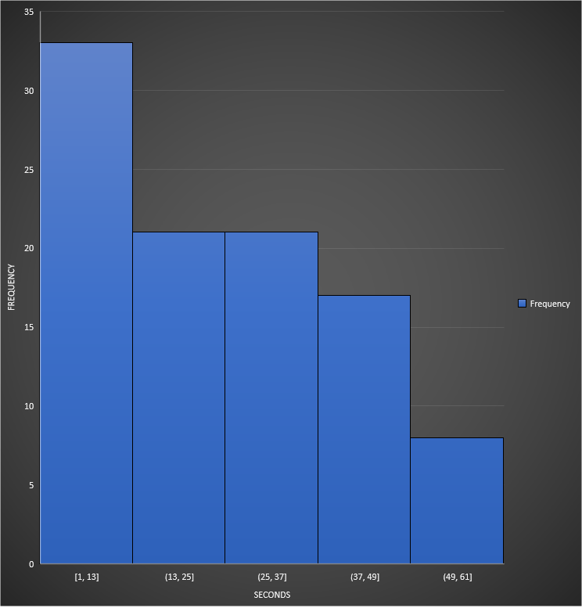**Histogram**

**Box Plot Chart**

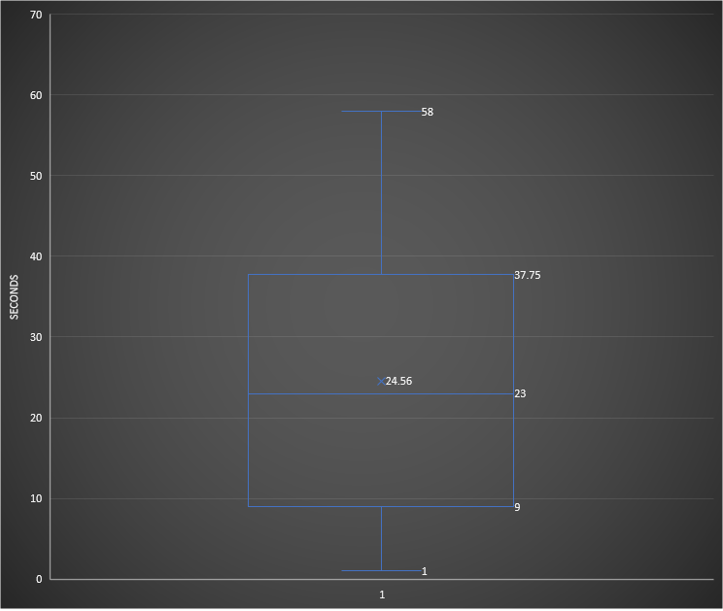**Quartile Values of X:**

**Q1: 9**

**Q2: 23**

**Q3: 37.75**

**Descriptive Statistics**

**Set 1:** The data set for the weight of 100 adult males appears to follow a normal distribution. If you look at the frequency table and histogram, you will see that both graphs follow a bell-shaped symmetrical curve that is centered around the mean.

**Set 2:** The data set for the inter-arrival time between 101 people entering a store appears to follow an exponential distribution. If you look at the frequency table and histogram, you will see that both graphs follow a downward line instead of a bell-shaped curve like normal distribution would be.